Question No | Average
1 | 6.8
2 | 4.7
3 | 6.7
4 | 12.2
5 | 8.3
6 | 8.1
7 | 7.0
8 | 9.3
9 | 10.9
10 | 7.2
11 | 7.4
12 | 7.6
13 | 8.1
14 | 6.8
15 | 5.4
16 | 7.0
17 | 8.5
18 | 4.1
19 | 4.0
20 | 10.3
21 | 8.4
22 | 6.9
23 | 9.1
24 | 10.1
25 | 7.5
26 | 8.8
27 | 2.8
28 | 7.3
Total | 211.3 (58.7%)
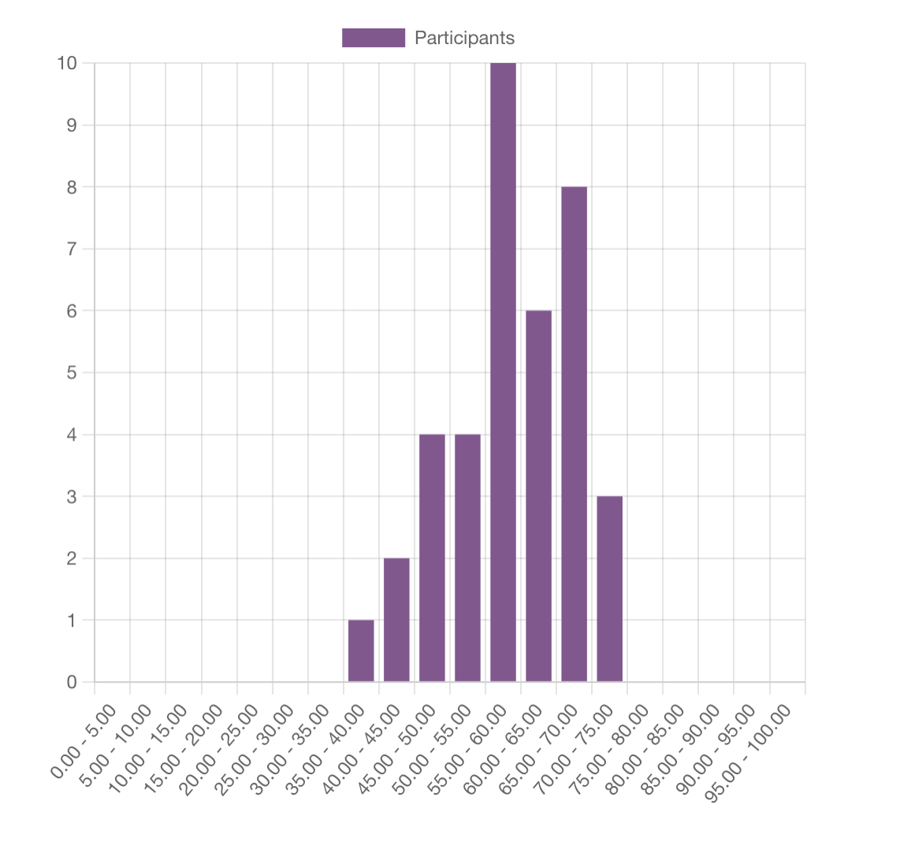
2025.1 SAQ Average Marks

